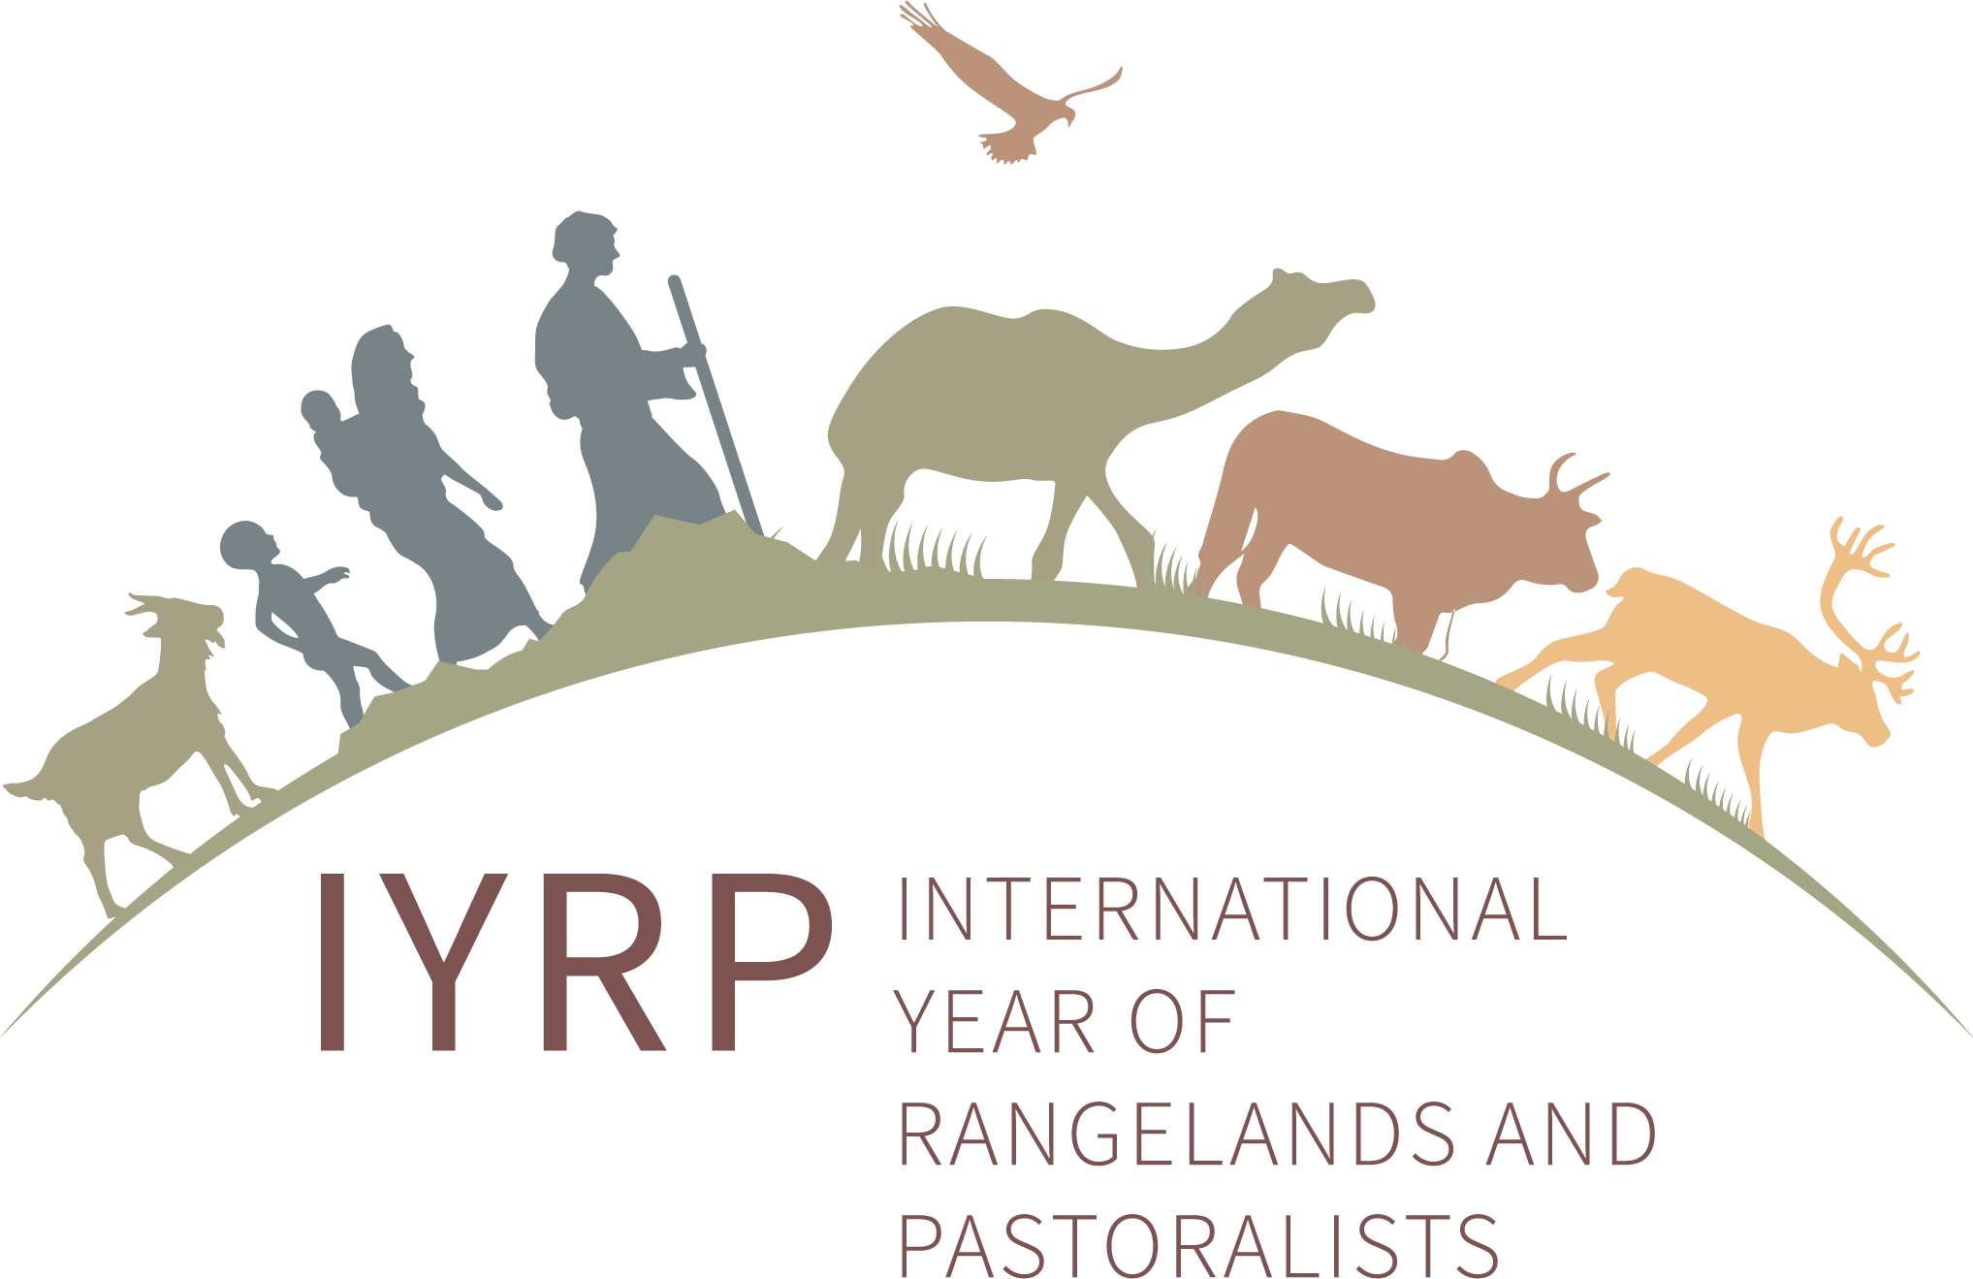
Working together towards grasslands sustainability

RISG Europe

Organised by the “Dinara back to life” project of the Association BIOM on 21–24 March 2023 in Croatia, the conference “Working together towards grasslands sustainability (cross-sectoral approach)” brought together stakeholders from different sectors such as nature conservation, forestry, agriculture, public authorities, pastoralists and local action groups to discuss opportunities and the importance of cross-sectoral cooperation in grassland management.
During the Conference, a specific workshop session was allocated to discuss regional actions for preserving mobile pastoralism and nature. Hosted by the co-chair of the Regional IYRP Support Group (RISG) in Europe, Engin Yilmaz of Yolda Initiative & AMNC, the session addressed the topics of:
- the current state of mobile pastoralism in Europe and Croatia
- mutual benefits and conflicts between (mobile) pastoralists and conservationists
- the root causes of the decline of mobile pastoralism (transhumance) in Europe and the differentiation of the practice towards unsustainable intensification
- the specific areas and goals of collaborative actions for achieving common objectives.
The results of this workshop will feed into the ongoing process of developing a European-level action plan for the IYRP.

